**DAILY ONLINE ACTIVITIES SUMMARY**

|  |  |  |  |  |
| --- | --- | --- | --- | --- |
| **Date:** | | **20-06-2020** | **Name:** | **Latika Kavoor** |
| **Sem & Sec** | | **4th Sem & A-Section** | **USN:** | **4AL18CS035** |
| **Online Test Summary** | | | | |
| **Subject** | **DC** | | | |
| **Max. Marks** | **30** | | **Score** | **28** |
| **Certification Course Summary** | | | | |
| **Course** | | **ENTREPRENEURSHIP** | | |
| **Certificate Provider** | | **CISCO** | **Duration** | **15 hrs** |
| **Coding Challenges** | | | | |
| **Problem Statement:Write a Java program to count number of bits to be flipped to convert A to B** | | | | |
| **Status: Completed** | | | | |
| **Uploaded the report in Github** | | | **Yes** | |
| **If yes Repository name** | | | <https://github.com/alvas-education-foundation/latika.kavoor/tree/master/coding_solutions> | |
| **Uploaded the report in slack** | | | **Yes** | |

Online Test Details: (Attach the snapshot and briefly write the report for the same)

DC test was conducted on 20-06-2020 for 30 marks

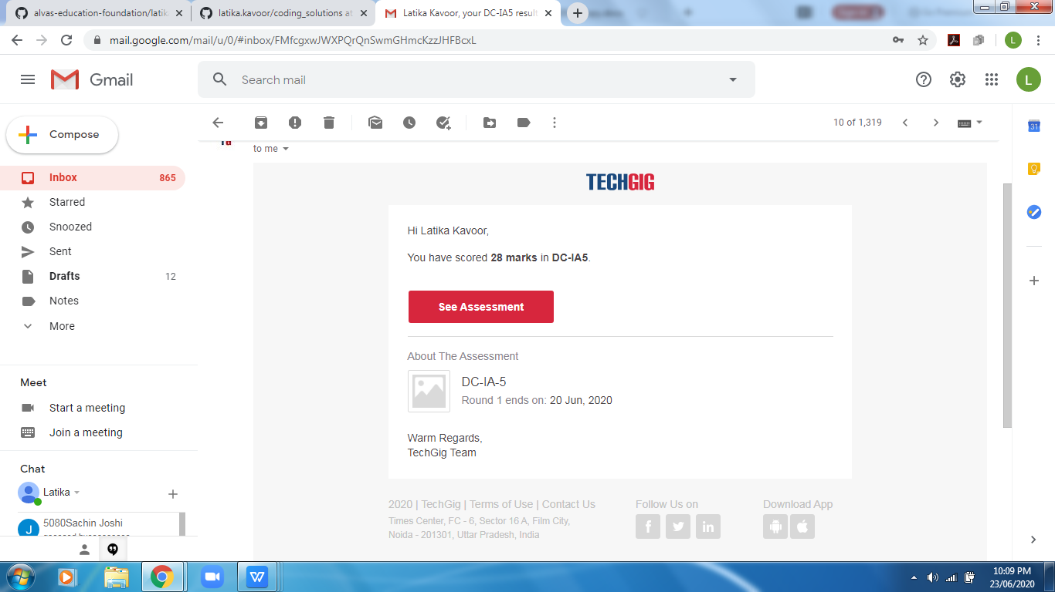

Certification Course Details: (Attach the snapshot and briefly write the report for the same)

Continuing the course and finishing with the module 1.

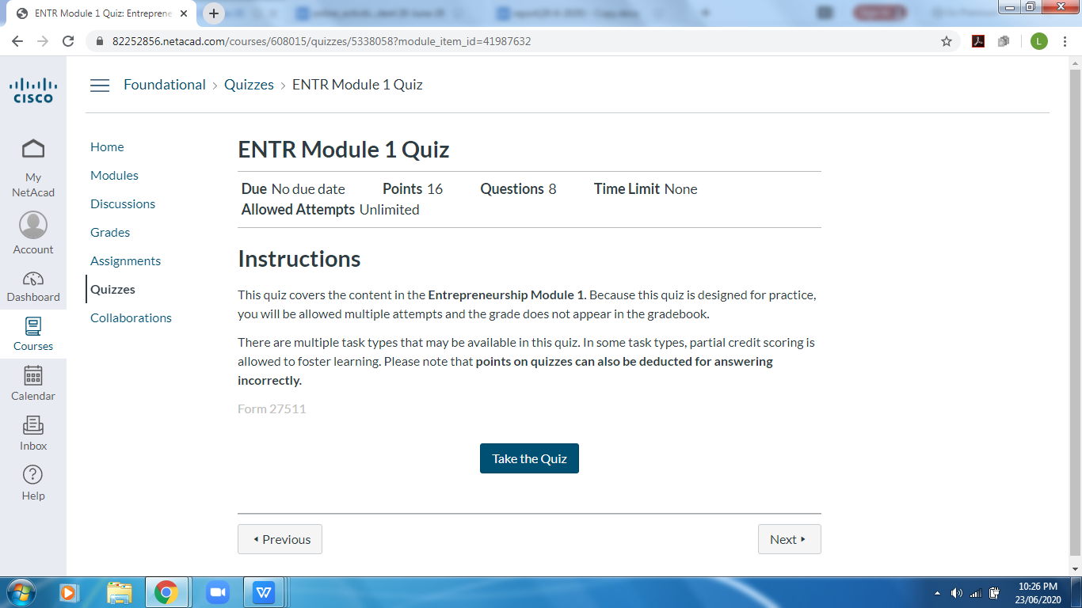

Coding Challenges Details: (Attach the snapshot and briefly write the report for the same)

Solved the problem and uploaded the same on Github

